
Date

:

Roll

No.

:

Page

No.

:

PRACTICE

4

PRACTICE

4.1.1

AIM:

Write

a

C

program

on

stack

and

its

operations

using

arrays
PROGRAM:

#include<stdio.h>

int

stack[5],i,top=
-
1
,ele;
void push()

{

if(top==4)

printf("stack

is

overflow");
else

{

top++;

printf("enter

an

element");
scanf("%d",&ele);
stack[top]=ele;

}

}

void

pop()

{

if(top==
-
1)

printf("Stack

is

undeflow");
else

{

ele=stack[top];

printf("Deleted

element

is

%d",ele);


Date

:

Roll

No.

:

24
B11AI
312

}

}

OUTPUT:

1
.push

2
.pop

3
.display

4
.exit
enter your choice1

enter

an

element10

1
.push

2
.pop

3
.display

4
.exit
enter your choice1

enter

an

element20

1
.push

2
.pop

3
.display

4
.exit
enter your choice1

enter

an

element30

1
.push

2
.pop

3
.display

4
.exit
enter your choice3

30

20

10

1
.push

2
.pop

3
.display

4
.exit
enter your choice2

Deleted

element

is

30

1
.push

2
.pop

3
.display

4
.exit
enter your choice4


Date

:

Roll

No.

:

24
B11AI
312

PRACTICE

4.1.2

AIM:

Write

a

C

program

on

stack

and

its

operations

using

LinkedList
PROGRAM:

#include<stdio.h>
#include<stdlib.h>
struct node

{

int

data;

struct

node

*next;

}
;

struct

node

*newnode=NULL;
struct node *top=NULL;
struct node *temp=NULL;
void push();

void pop();
void

display();
int ele;

void

main()

{

int ch;
while(1)

{

printf("
\
nstack operations
\
n");
printf("1.push

2
.pop

3
.display

4
.exit
\
n");
printf("Enter your choice
\
n");


Date

:

Roll

No.

:

24
B11AI
312

scanf("%d",&ch);
switch(ch)

{

case

1:
push();
break;

case

2:
pop();
break;

case

3:
display();
break;

default:

exit(0);
break;

}

}

}

void

push()

{

newnode=(struct

node*)malloc(sizeof(struct

node));
printf("Enter data
\
n");

scanf("%d",&ele);
if(top==NULL)

{

newnode
-
>
data=ele;
newnode
-
>
next=NULL;
top=newnode;

}

else


Date

:

Roll

No.

:

24
B11AI
312

{

newnode
-
>
data=ele;
newnode
-
>
next=top;
top=newnode;

}

}

void

pop()

{

if(top==NULL)
printf("Stack

is

empty");
else

{

temp=top;
ele=top
-
>
data;

printf("Deleted

element

is

%d
\
n",ele);
top=top
-
>
next;

temp
-
>
next=NULL;
free(temp);

}

}

void

display()

{

if(top==NULL)
printf("Stack

is

empty");
else

{


Date

:

Roll

No.

:
24
B11AI
312

printf("The

stack

elements

are:
\
n");
temp=top;

while(temp!=NULL)

{

printf("%d
-
>
",

temp
-
>
data);
temp=temp
-
>
next;

}

printf("NULL");

}

}

OUTPUT:

stack

operations

1
.push

2
.pop

3
.display

4
.exit
Enter your choice

1

Enter

data
10

stack

operations

1
.push

2
.pop

3
.display

4
.exit
Enter your choice

1

Enter

data
20

stack

operations


Date

:

Roll

No.

:

B11AI
24
312

1
.push

2
.pop

3
.display

4
.exit
Enter your choice

1

Enter

data
30

stack

operations

1
.push

2
.pop

3
.display

4
.exit
Enter your choice

3

The

stack

elements

are:
30
-
>20
-
>10
-
>
NULL

stack

operations

1
.push

2
.pop

3
.display

4
.exit
Enter your choice

2

Deleted

element

is

30

stack

operations

1
.push

2
.pop

3
.display

4
.exit
Enter your choice

4


Date

:

Roll

No.

:

24
B11AI
312

Page

No.

:

PRACTICE

4.2

AIM:

Write

a

C

program

to

evaluate

a

postfix

expression
PROGRAM:

#include<stdio.h>
#include<stdlib.h>
#include<ctype.h>
#define MAX 20
void push(int);

int

pop();

int

evaluationofpostfix(char*);
int stack[MAX], top =
-
;
1

void push(int n)

{

stack[++top]

=

n;

}

int

pop()

{

return

stack[top
--
]
;

}

int

evaluationofpostfix(char

*ex)

{

int

d =

0
,

s =

0
,

i;

for

i
(

=

0
;

ex[i]

!=

'
\
';
0
i++)

{

if

(
isdigit(ex[i]))
d++;

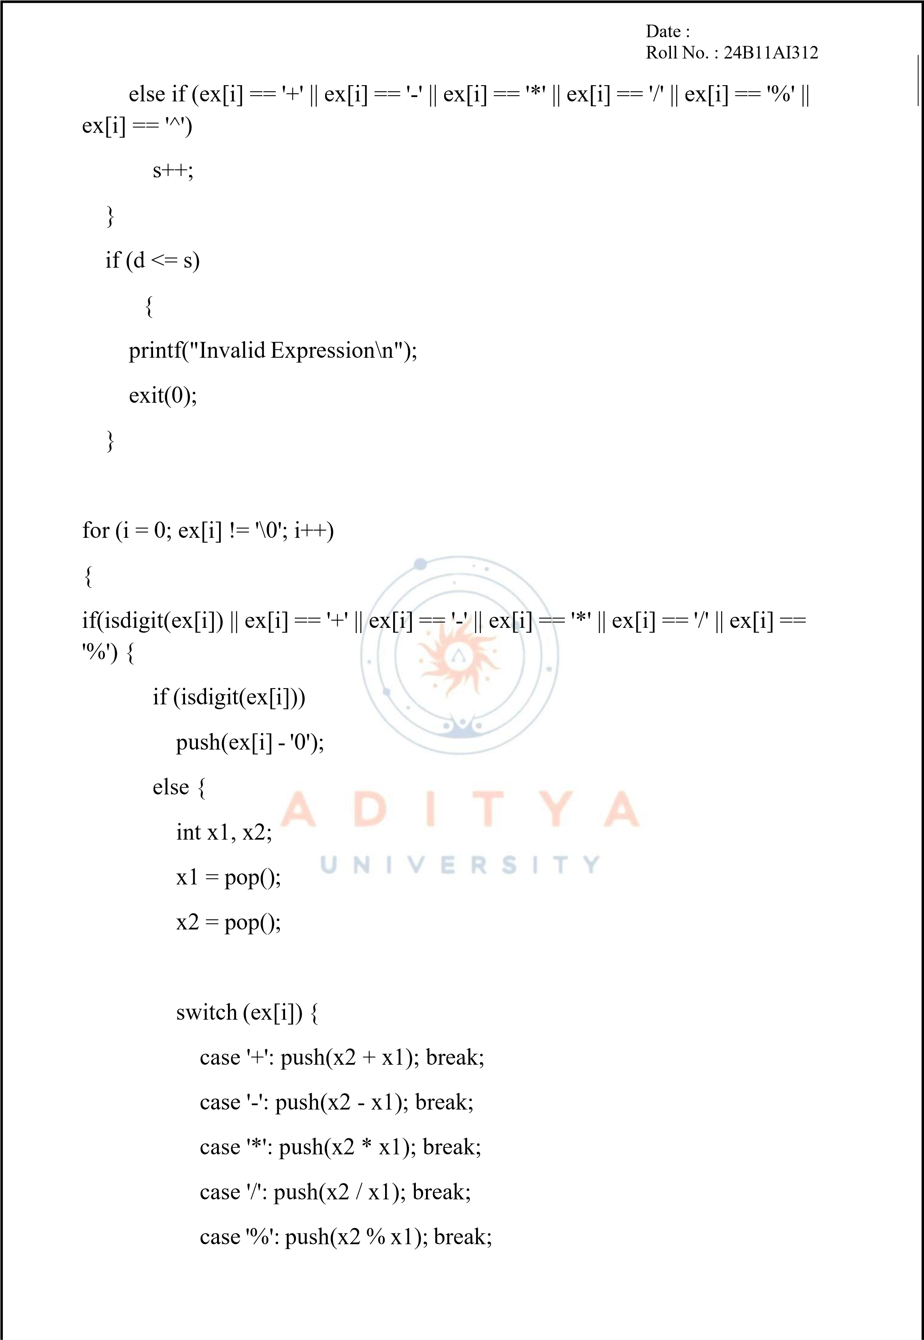

Date

:

Roll

No.

:
24
B11AI
312

}

}

}

else
{

printf("Invalid

expression
\
n");
exit(0);

}

}

if

(
top
!=

0)

{

printf("Invalid

expression
\
n");
exit(0);

}

else

{

return

stack[top];

}

}

int

main()

{

char

exp[MAX];

printf("Enter

a

valid

postfix

expression:

");
gets(exp);

printf("Result

of

postfix

evaluation

is

%d
\
n",

evaluationofpostfix(exp));
return 0;

}


Date

:

Roll

No.

:

24
B11AI
312

OUTPUT:

Enter

a

valid

postfix

expression:

234+
*
Result of postfix evaluation is 14


Date

:

Roll

No.

:

24
B11AI
312

Page

No.

:

PRACTICE

4.3.1

AIM:

Write

a

C

program

on

Queue

and

its

operations

using

arrays
PROGRAM:

#include <stdio.h>
#include

<
stdlib.h>
#define SIZE 5

int

queue[SIZE],

f

=

-
1
,

r

=

-
,
1

ele;
void enq();

void deq();
void

display();
int main()

{

int ch;
while

(1)

{

printf("
\
n1.Enq

2
.Deq

3
.Display

.Exit
4
\
n");
printf("Enter your choice: ");

scanf("%d",

&ch);
switch (ch)

{

case

1:

enq();

break;
case

2:

deq();

break;


Date

:

Roll

No.

:

24
B11AI
312

Page

No.

:

case

3:

display();

break;
case 4: exit(0);

default:

printf("Invalid

choice
\
n");

}

}

return

0
;

}

void

enq()

{

if

(
r

==

SIZE

-

1)

{

printf("Queue

is

Full
\
n");

}

else

{

printf("Enter

an

element:

");
scanf("%d", &ele);

if

(
f

==

-
1)

f

=

0
;

//

Only

set

f=0

for

the

first

insertion
queue[++r] = ele;

}

}

void

deq()

{


Date

:

Roll

No.

:

24
B11AI
312

Page

No.

:

if

(
f

==

-
||
1

f

>

r)

{

printf("Queue

is

Empty
\
n");

}

else

{

ele

=

queue[f];
f++;

printf("Deleted

Element

is

%d
\
n",

ele);

if

(
f

>

r)

f

=

r

=

-
;
1

//

Reset after

last

element

is

removed

}

}

void

display()

{

int

i;

if

(
f

==

-
||
1

f

>

r)

{

printf("Queue

is

Empty
\
n");

}

else

{

printf("Queue

elements:

");
for(i = f; i <= r; i++)

printf("%d

",

queue[i]);
printf("
\
n");

}


Date

:

Roll

No.

:

24
B11AI
312

Page

No.

:

}

OUTPUT:

.Enq
1

2
.Deq

3
.Display

4
.Exit
Enter your choice: 1

Enter

an

element:

10

1
.Enq

2
.Deq

3
.Display

4
.Exit
Enter your choice: 1

Enter

an

element:

20

.Enq
1

2
.Deq

3
.Display

4
.Exit
Enter your choice: 1

Enter

an

element:

30

1
.Enq

2
.Deq

3
.Display

4
.Exit
Enter your choice: 3

Queue

elements:

10

20

30

1
.Enq

2
.Deq

.Display
3

4
.Exit
Enter your choice: 2

Deleted

Element

is

10

1
.Enq

2
.Deq

3
.Display

4
.Exit
Enter your choice: 4


Date

:

Roll

No.

:

B11AI
24
312

Page

No.

:

PRACTICE

4.3.2

AIM:

Write

a

C

program

on

Queue

and

its

operations

using

LinkedList
PROGRAM:

#include <stdio.h>
#include

<
stdlib.h>
struct Node

{

int

data;

struct

Node*

next;

;
}

struct

Node

*front

=

NULL;
struct Node *rear = NULL;
void enq();

void deq();
void

display();
int main()

{

int ch;
while

(1)

{

printf("
\
n1.Enq

2
.Deq

.Display
3

4
.Exit
\
n");
printf("Enter your choice: ");

scanf("%d",

&ch);
switch (ch)

{

case

1:

enq();

break;


Date

:

Roll

No.

:

B11AI
24
312

case 2: deq(); break;
case

3:

display();

break;
case 4: exit(0);

default:

printf("Invalid

choice
\
n");

}

}

return

0
;

}

void

enq()

{

int ele;

struct

Node

*newNode

=

(
struct

Node*)malloc(sizeof(struct

Node));
if (newNode == NULL) {

printf("Memory

not

allocated
\
n");
return;

}

printf("Enter

an

element:

");
scanf("%d", &ele);
newNode
-
>
data = ele;
newNode
-
>
next = NULL;

if

(
rear

==

NULL)

{

front

=

rear

=

newNode;

}

else


Date

:

Roll

No.

:

24
B11AI
312

Page

No.

:

{

rear
-
next
>

=

newNode;
rear = newNode;

}

}

void

deq()

{

if

==
(
front

NULL)

{

printf("Queue

is

Empty
\
n");
return;

}

struct

Node

*temp

=

front;

printf("Deleted

Element

is

%d
\
n",

front
-
>
data);
front = front
-
>
next;

free(temp);

if

(
front

==

NULL)
rear = NULL;

}

void

display()

{

struct

Node*

temp

=

front;
if (front == NULL) {

printf("Queue

is

Empty
\
n");


Date

:

Roll

No.

:

B11AI
24
312

return;

}

printf("Queue

elements:

");
while (temp != NULL)

{

printf("%d

",

temp
-
>
data);
temp = temp
-
>
next;

}

printf("
\
n");

}

OUTPUT:

1
.Enq

2
.Deq

3
.Display

4
.Exit
Enter your choice: 1

Enter

an

element:

10

1
.Enq

2
.Deq

3
.Display

4
.Exit
Enter your choice: 1

Enter

an

element:

20

1
.Enq

2
.Deq

3
.Display

4
.Exit
Enter your choice: 1

Enter

an

element:

30

1
.Enq

2
.Deq

3
.Display

4
.Exit
Enter your choice: 3


Date

:

Roll

No.

:

24
B11AI
312

Page

No.

:

Queue

elements:

10

20

30

1
.Enq

2
.Deq

3
.Display

4
.Exit
Enter your choice: 2

Deleted

Element

is

10

1
.Enq

2
.Deq

3
.Display

4
.Exit
Enter your choice: 4
PRACTICE 4.4

AIM:

Write

a

C

program

on

Circular

Queue

and

its

operations

using

arrays
PROGRAM:

#include <stdio.h>
#include

<
stdlib.h>
#define SIZE 5

int

queue[SIZE],

f

=

-
,
1

r

=

-
1
,

ele;

void enq();
void deq();
void

display();

int main() {
int ch;
while

(1)

{

printf("
\
n1.Enq

2
.Deq

3
.Display

4
.Exit
\
n");


Date

:

Roll

No.

:

24
B11AI
312

printf("Enter

your

choice:

");
scanf("%d", &ch);

switch

(
ch
)

{

case 1: enq(); break;
case 2: deq(); break;
case

3:

display();

break;
case 4: exit(0);

default:

printf("Invalid

choice
\
n");

}

}

return

0
;

}

void

enq()

{

//

Check

if

the

queue

is

full

if

((
f

==

0

&&

r

==

SIZE

-

1)

||

(
r

+

1

==

f))

{

printf("Queue is Full
\
n");

}

else

{

printf("Enter

an

element:

");
scanf("%d", &ele);

if

(
f

==

-
1)

{

f = r = 0;

}

else
{

r++;

if

(
r

>

SIZE

-
1)


Date

:

Roll

No.

:

24
B11AI
312

Page

No.

:

r =

0
;

}

queue[r]

=

ele;

}

}

void

deq()

{

if

(
f

==

-

1)
{

printf("Queue

is

Empty
\
n");

}

else

{

ele

=

queue[f];

printf("Deleted

Element

is

%d
\
n",

ele);
if (f == r) {

//

Only

one

element

was

there
f = r =
-
1
;

}

else
{

f++;

if

(
f

>

SIZE

-

1)

f = 0;

}

}

}

void

display()

{

if

(
f

==

-

1)
{

printf("Queue

is

Empty
\
n");


Date

:

Roll

No.

:

24
B11AI
312

}

else

{

printf("Queue

elements:

");
int i = f;

while

(1)

{

printf("%d

",

queue[i]);
if (i == r)

break;
i++;

if

(
i

>

SIZE

-

1)

i = 0;

}

printf("
\
n");

}

}

OUTPUT:

1
.Enq

2
.Deq

3
.Display

4
.Exit
Enter your choice: 1

Enter

an

element:

10

1
.Enq

2
.Deq

3
.Display

4
.Exit
Enter your choice: 1

Enter

an

element:

20

1
.Enq

2
.Deq

3
.Display

4
.Exit
Enter your choice: 1

Enter

an

element:

30

Date

:

Roll

No.

:

24
B11AI
312

1
.Enq

2
.Deq

3
.Display

4
.Exit
Enter your choice: 1

Enter

an

element:

40

1
.Enq

2
.Deq

3
.Display

4
.Exit
Enter your choice: 1

Enter

an

element:

50

1
.Enq

2
.Deq

3
.Display

4
.Exit
Enter your choice: 3

Queue

elements:

10

20

30

40

50

1
.Enq

2
.Deq

3
.Display

4
.Exit
Enter your choice: 2

Deleted

Element

is

10

1
.Enq

2
.Deq

3
.Display

4
.Exit
Enter your choice: 1

Enter

an

element:

60

1
.Enq

2
.Deq

3
.Display

4
.Exit
Enter your choice: 3

Queue

elements:

20

30

40

50

60

1
.Enq

2
.Deq

3
.Display

4
.Exit
Enter your choice:4

Date :
Roll No. : 24B11AI312

